Session 1
Q1. Open Instagram's home page in Chrome, right-click on a post image, and use Inspect Element to find the exact HTML tag and CSS class used for the image container. Write down the tag name and class.
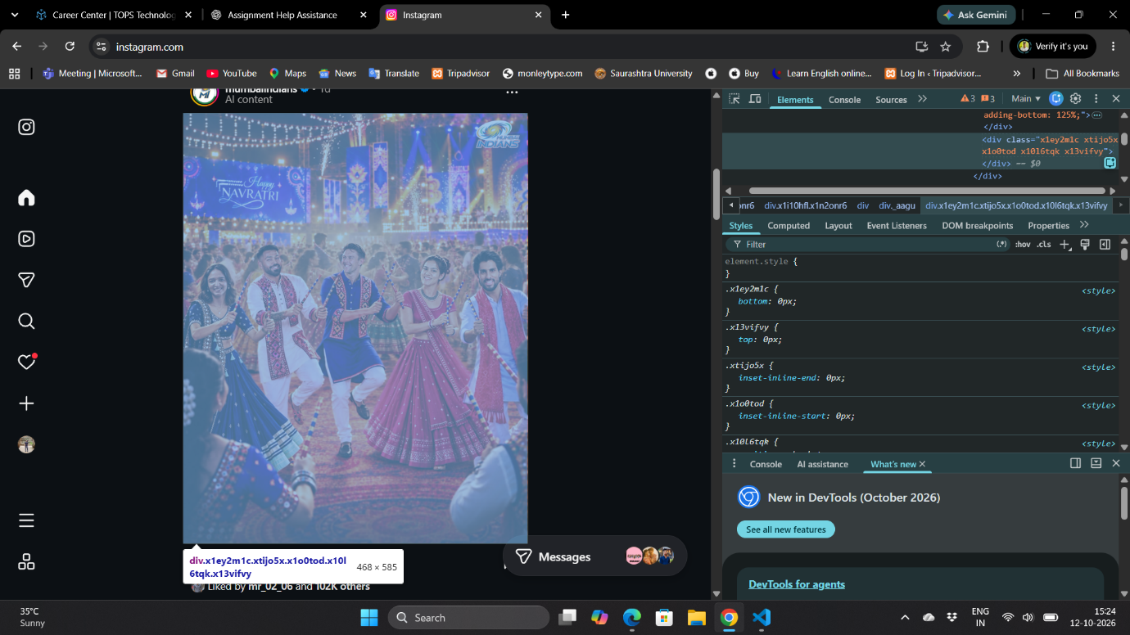

Q3. Use Chrome DevTools to change the background color of your name (in myprofile.html) to any color you like, live in the browser, without editing the HTML file.
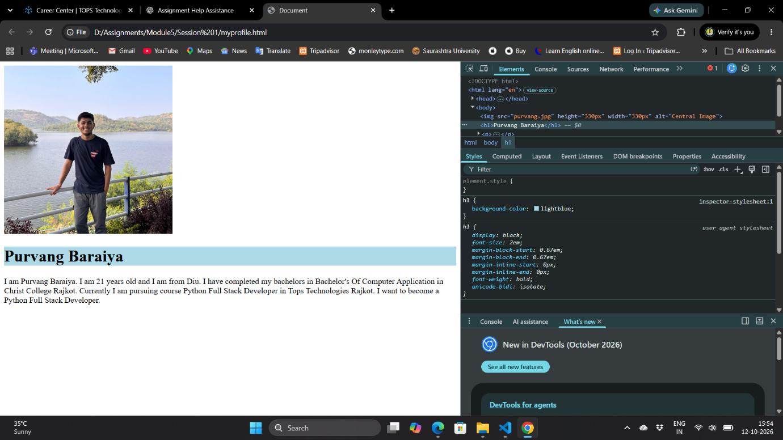

Q4. Draw a diagram or write a list showing the DOM structure (parent-child relationships) of your myprofile.html page. Include at least 3 levels (html > body > your content).
html
├── head
│ └── title
│ └── "My Profile"
│
└── body
├── h1
│ └── "Purvang"
│
├── img
│
└── p
└── "I am Purvang Baraiya. I am 21 years old and I am from Diu. I have completed my bachelors in Bachelor's Of Computer Application in Christ College Rajkot. Currently I am pursuing course Python Full Stack Developer in Tops Technologies Rajkot. I want to become a Python Full Stack Developer."

